Java AWT
AWT stands for Abstract Window Toolkit. It is a platform dependent API for creating Graphical User Interface (GUI) for java programs.
Why AWT is platform dependent? Java AWT calls native platform (Operating systems) subroutine for creating components such as textbox, checkbox, button etc. For example an AWT GUI having a button would have a different look and feel across platforms like windows, Mac OS & Unix, this is because these platforms have different look and feel for their native buttons and AWT directly calls their native subroutine that creates the button. In simple, an application build on AWT would look like a windows application when it runs on Windows, but the same application would look like a Mac application when runs on Mac OS.
AWT is rarely used now days because of its platform dependent and heavy-weight nature. AWT components are considered heavy weight because they are being generated by underlying operating system (OS). For example if you are instantiating a text box in AWT that means you are actually asking OS to create a text box for you.
Swing is a preferred API for window based applications because of its platform independent and light-weight nature. Swing is built upon AWT API however it provides a look and feel unrelated to the underlying platform. It has more powerful and flexible components than AWT. In addition to familiar components such as buttons, check boxes and labels, Swing provides several advanced components such as tabbed panel, scroll panes, trees, tables, and lists. We will discuss Swing in detail in a separate tutorial.

AWT hierarchy
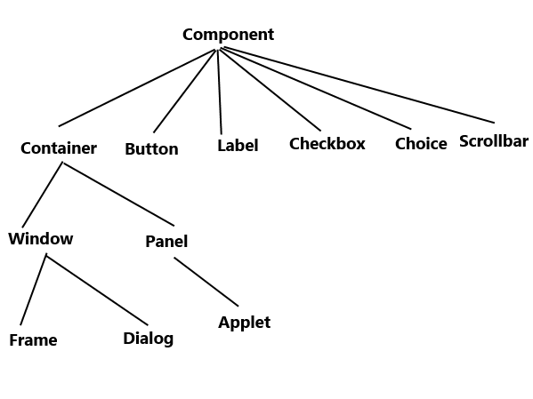

Components and containers
All the elements like buttons, text fields, scrollbars etc are known as components. In AWT we have classes for each component as shown in the above diagram. To have everything placed on a screen to a particular position, we have to add them to a container. A container is like a screen wherein we are placing components like buttons, text fields, checkbox etc. In short a container contains and controls the layout of components. A container itself is a component (shown in the above hierarchy diagram) thus we can add a container inside container.
Types of containers:
As explained above, a container is a place wherein we add components like text field, button, checkbox etc. There are four types of containers available in AWT: Window, Frame, Dialog and Panel. As shown in the hierarchy diagram above, Frame and Dialog are subclasses of Window class.
Window: An instance of the Window class has no border and no title
Dialog: Dialog class has border and title. An instance of the Dialog class cannot exist without an associated instance of the Frame class.
Panel: Panel does not contain title bar, menu bar or border. It is a generic container for holding components. An instance of the Panel class provides a container to which to add components.
Frame: A frame has title, border and menu bars. It can contain several components like buttons, text fields, scrollbars etc. This is most widely used container while developing an application in AWT.

Java AWT Example
We can create a GUI using Frame in two ways:
1) By extending Frame class
2) By creating the instance of Frame class

AWT Example 1: creating Frame by extending Frame class
import java.awt.*;
/* We have extended the Frame class here,
* thus our class "SimpleExample" would behave
* like a Frame
*/
public class SimpleExample extends Frame{
SimpleExample(){
Button b=new Button("Button!!");

// setting button position on screen
b.setBounds(50,50,50,50);

//adding button into frame
add(b);

//Setting Frame width and height
setSize(500,300);

//Setting the title of Frame
setTitle("This is my First AWT example");

//Setting the layout for the Frame
setLayout(new FlowLayout());

/* By default frame is not visible so
* we are setting the visibility to true
* to make it visible.
*/
setVisible(true);
}
public static void main(String args[]){
// Creating the instance of Frame
SimpleExample fr=new SimpleExample();
}
}
Output:
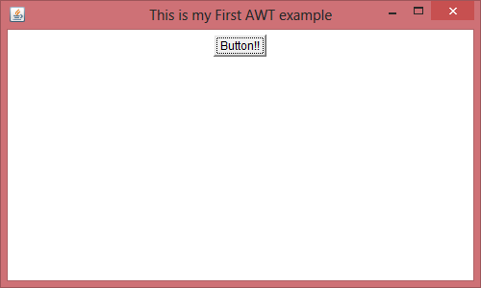

AWT Example 2: creating Frame by creating instance of Frame class
import java.awt.*;
public class Example2 {
Example2()
{
//Creating Frame
Frame fr=new Frame();

//Creating a label
Label lb = new Label("UserId: ");

//adding label to the frame
fr.add(lb);

//Creating Text Field
TextField t = new TextField();

//adding text field to the frame
fr.add(t);

//setting frame size
fr.setSize(500, 300);

//Setting the layout for the Frame
fr.setLayout(new FlowLayout());

fr.setVisible(true);
}
public static void main(String args[])
{
Example2 ex = new Example2();
}
}
Output:
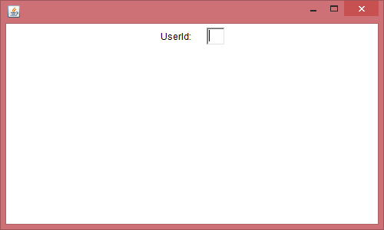

Layout Manager- A layout manager is an object that implements the LayoutManager interface* and determines the size and position of the components within a container. Although components can provide size and alignment hints, a container's layout manager has the final say on the size and position of the components within the container. Several layout managers are available in java for general use.
Several AWT and Swing classes provide layout managers for general use:
- BorderLayout.
- BoxLayout.
- CardLayout.
- FlowLayout.
- GridBagLayout.
- GridLayout.
- GroupLayout.
- SpringLayout.

FlowLayout
Flow layout is the default layout, which means if you don’t set any layout in your code then layout would be set to Flow by default. Flow layout puts components (such as text fields, buttons, labels etc) in a row, if horizontal space is not enough to hold all components then Flow layout adds them in a next row and so on.
Example: Here is the image of a Frame where eight buttons have been added to a Frame under Flow layout. As you can see buttons 7 & 8 are in second row because first six buttons consumed all horizontal space.
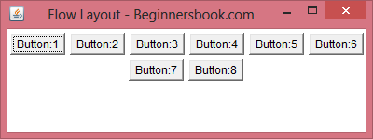
Points to Note:
- All rows in Flow layout are center aligned by default. As you can see in the above image that buttons 7 & 8 are in center. However we can set the alignment to left or right, we will learn about it later in this post.
- The default horizontal and vertical gap between components is 5 pixels.
- By default the components Orientation is left to right, which means the components would be added from left to right, however we can change it to right to left as well, we will see that later in this post.

Simple Flow Layout Example
The image shown above is the output of this code. Here we are adding 8 buttons to a Frame and layout is being set to FlowLayout.
import java.awt.*;
public class FlowLayoutDemo extends Frame{
// constructor
public FlowLayoutDemo(String title)
{
/* It would create the Frame by calling
* the constructor of Frame class.
*/
super(title);

//Setting up Flow Layout
setLayout(new FlowLayout());

//Creating a button and adding it to the frame
Button b1 = new Button("Button:1");
add(b1);

/* Adding other components to the Frame
*/
Button b2 = new Button("Button:2");
add(b2);

Button b3 = new Button("Button:3");
add(b3);

Button b4 = new Button("Button:4");
add(b4);

Button b5 = new Button("Button:5");
add(b5);

Button b6 = new Button("Button:6");
add(b6);

Button b7 = new Button("Button:7");
add(b7);

Button b8 = new Button("Button:8");
add(b8);
}
public static void main(String[] args)
{ FlowLayoutDemo screen =
new FlowLayoutDemo("Flow Layout - Beginnersbook.com");
screen.setSize(400,150);
screen.setVisible(true);
}
}

Flow Layout where Orientation is right to left
The default Orientation for flow layout is left to right, however we can set it to right to left if want.
import java.awt.*;
public class FlowLayoutDemo extends Frame{
// constructor
public FlowLayoutDemo(String title)
{
/* It would create the Frame by calling
* the constructor of Frame class.
*/
super(title);

//Setting up Flow Layout
setLayout(new FlowLayout());

//Creating a button and adding it to the frame
Button b1 = new Button("Button:1");
add(b1);

/* Adding other components to the Frame
*/
Button b2 = new Button("Button:2");
add(b2);

Button b3 = new Button("Button:3");
add(b3);

Button b4 = new Button("Button:4");
add(b4);

Button b5 = new Button("Button:5");
add(b5);

Button b6 = new Button("Button:6");
add(b6);

Button b7 = new Button("Button:7");
add(b7);

Button b8 = new Button("Button:8");
add(b8);
/* This would set the Orientation to
* RightToLeft
*/
setComponentOrientation(
ComponentOrientation.RIGHT_TO_LEFT);

}
public static void main(String[] args)
{ FlowLayoutDemo screen =
new FlowLayoutDemo("Flow Layout - Beginnersbook.com");
screen.setSize(400,150);
screen.setVisible(true);
}
}
Output:
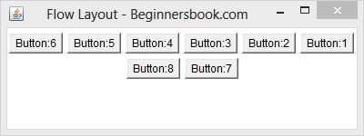

Left alignment of components in FlowLayout
As we have seen in the examples above that the rows are center aligned (look at the buttons 7 & 8 in the image above). However we can change the alignment by passing the parameters to the constructor of flow layout while setting up the layout.
To change the alignment to Left, replace the statement setLayout(new FlowLayout()); with this one: setLayout(new FlowLayout(FlowLayout.LEFT)); in the example 1. The output would look like the image below –
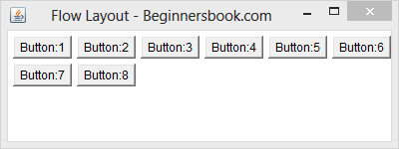

Right alignment of components in FlowLayout
To change the alignment to Right, replace the statement setLayout(new FlowLayout()); with this one: setLayout(new FlowLayout(FlowLayout.RIGHT)); in the example 1. The output would look like the image below –
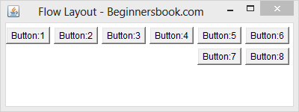

Border Layout
In Border layout we can add components (such as text fields, buttons, labels etc) to the five specific regions. These regions are called PAGE_START, LINE_START, CENTER, LINE_END, PAGE_END. Refer the diagram below to understand their location on a Frame.
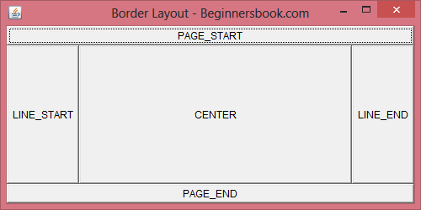
The diagram above is the output of below code, where I have added five buttons (which have same name as regions in which they have been placed) to the five regions of Border Layout. You can add any component of your choice in a similar manner.
package com.beginnersbook.layout;
import java.awt.*;
public class BorderDemo extends Frame{
// constructor
public BorderDemo(String title)
{
/* It would create the Frame by calling
* the constructor of Frame class.
*/
super(title);

//Setting up Border Layout
setLayout(new BorderLayout());

//Creating a button and adding it to PAGE_START area
Button b1 = new Button("PAGE_START");
add(b1, BorderLayout.PAGE_START);

/* Similarly creating 4 other buttons and adding
* them to other 4 areas of Border Layout
*/
Button b2= new Button("CENTER");
add(b2, BorderLayout.CENTER);

Button b3= new Button("LINE_START");
add(b3, BorderLayout.LINE_START);

Button b4= new Button("PAGE_END");
add(b4, BorderLayout.PAGE_END);

Button b5= new Button("LINE_END");
add(b5, BorderLayout.LINE_END);
}
public static void main(String[] args)
{ BorderDemo screen =
new BorderDemo("Border Layout - Beginnersbook.com");
screen.setSize(500,250);
screen.setVisible(true);
}
}
Note: The name of buttons in the example above are intentionally set same as region names, this is just for educational purpose, you can name them as per your wish and requirement.

What if you want spaces among regions?
In the example above, we do not have any space among regions; however we can have horizontal as well as vertical space between regions. There are two ways to do it –
1) Notice the statement setLayout(new BorderLayout( )); in the example above, if you change it to this: setLayout(new BorderLayout(50,20)); then the output Frame would look like the image below. Here 50 is horizontal gap and 20 is vertical gap.
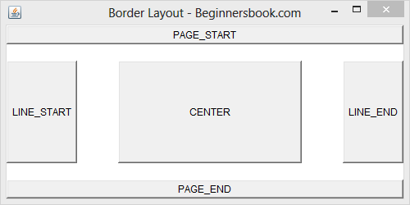
Method details:
public BorderLayout(int hgap, int vgap)
Constructs a border layout with the specified gaps between components. The horizontal gap is specified by hgap and the vertical gap is specified by vgap.
Parameters:
hgap – the horizontal gap.
vgap – the vertical gap.
2) You can also do it by using setHgap(int hgap) method for horizontal gap between components and setVgap(int vgap) method for vertical gap.

